Step to activate the service for the new location(panchayat)

1. Login as a panchayat department admin(DA) user for particular panchayat.ex-WB000183. Assign the roles one by one.

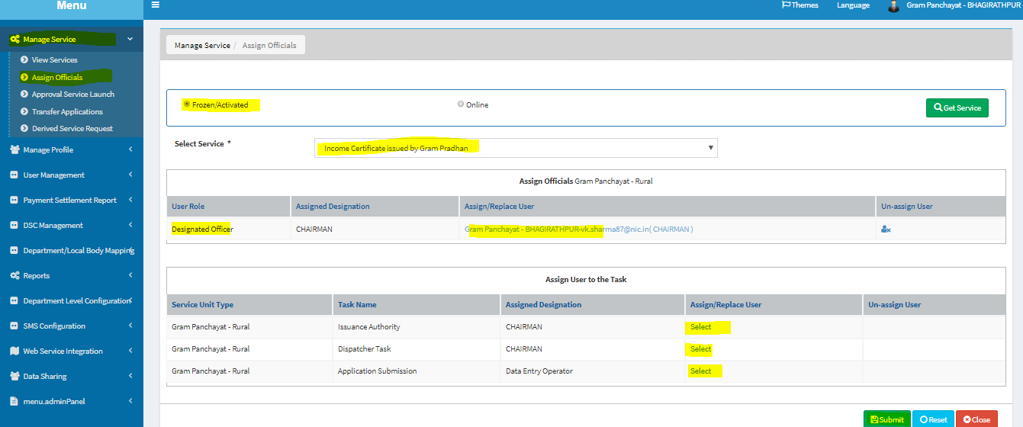

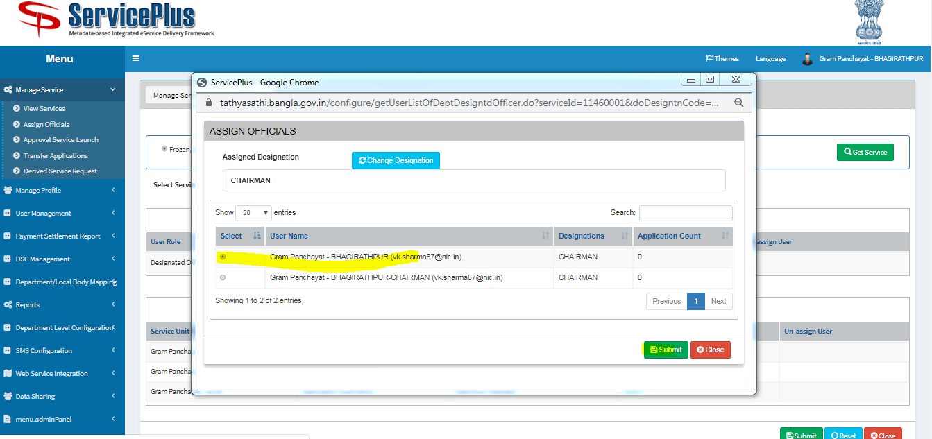

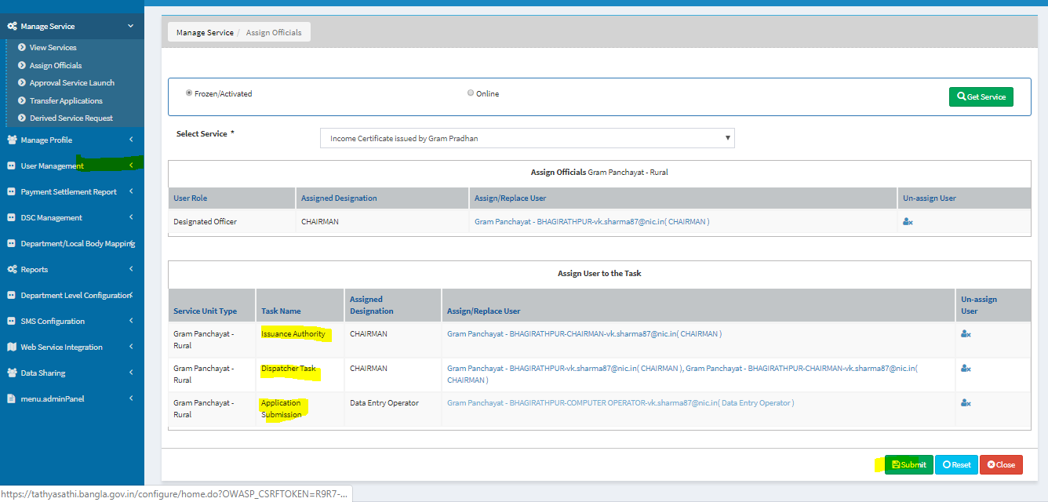

After click on submit button.Logout and again login as a panchayat department admin(DA) user for particular panchayat.ex-WB000183.click on modify

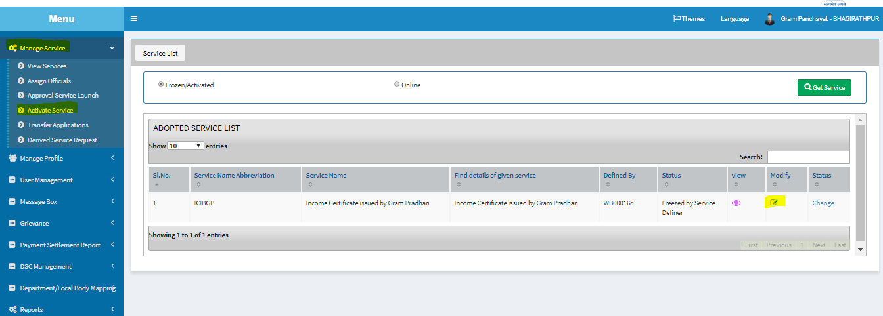

Select the service unit in mode of submission tab and fill the address fields and click on ADD button

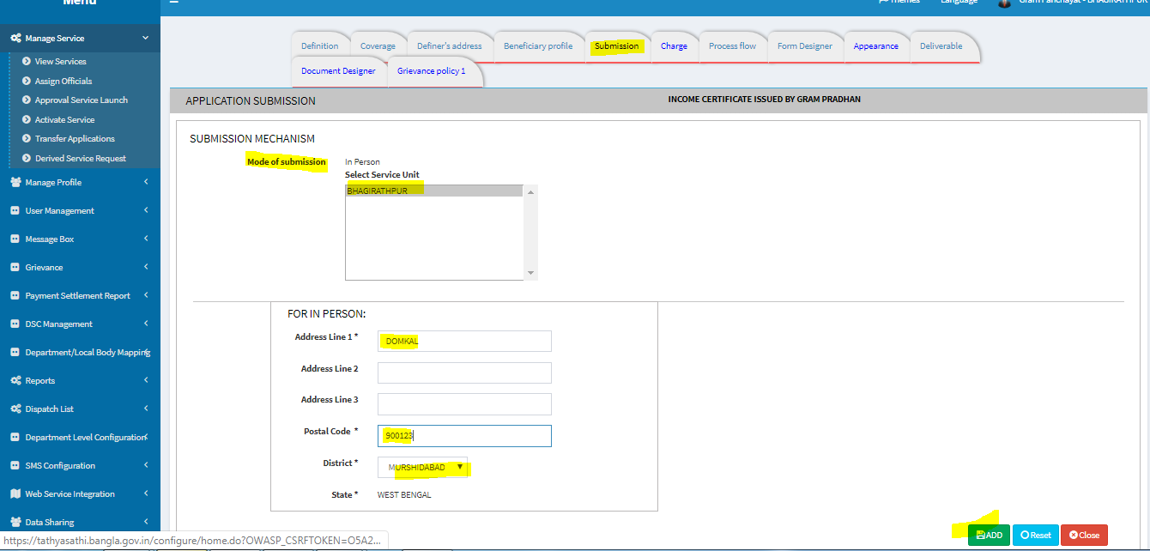

And again select “activate service’ tab and click on “change”

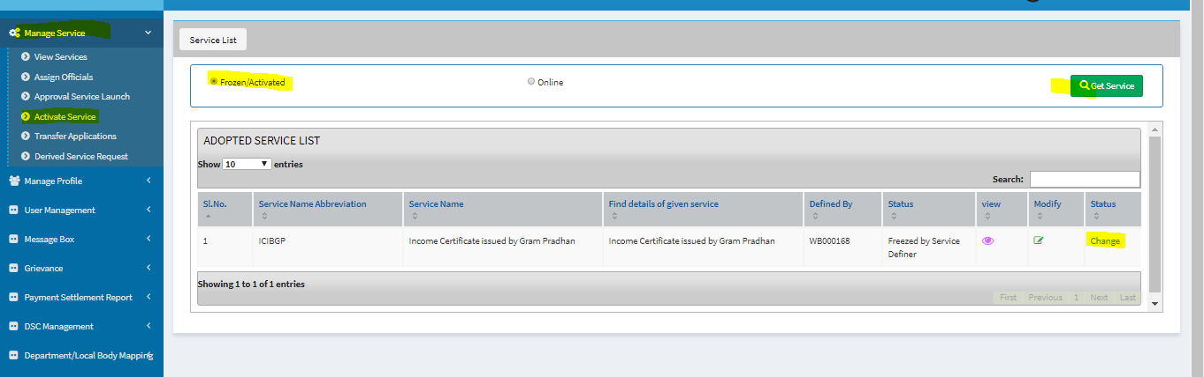

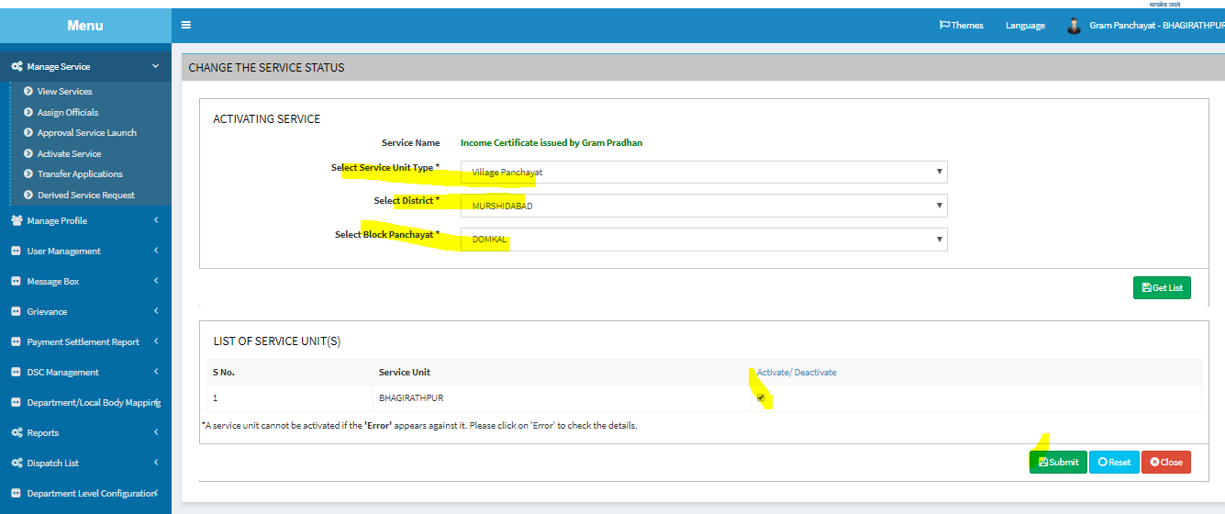

Service successfully activated.

